Project Design Phase
Solution Architecture

Date | 13 February 2026
Team ID | LTVIP2026TMIDS66236
Project Name | Explore With Ai: Custom Itineraries For Your Next Journey
Maximum Marks | 4 Marks

Solution Architecture:
The solution architecture of Explore with AI bridges the gap between the problem of manual travel planning and the implementation of an AI-powered automated system.
The architecture is designed to be lightweight, modular, and scalable. It integrates a web-based user interface with backend application logic and a cloud-based generative AI service.

Solution Architecture Diagram:

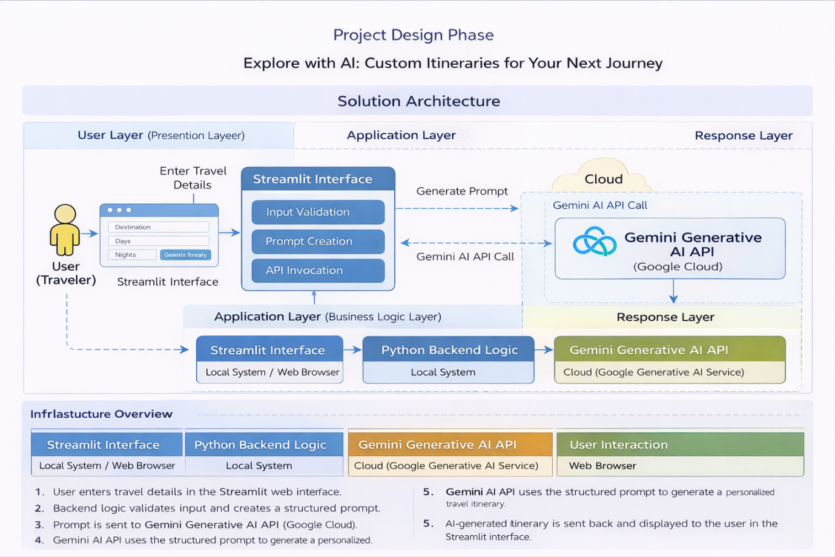

Figure 1: Architecture and data flow of travel itinerary application
Reference: https://aws.amazon.com/blogs/industries/voice-applications-in-clinical-research-powered-by-ai-on-aws-part-1-architecture-and-design-considerations/

